Jquery Documentation

Difference between library and framework

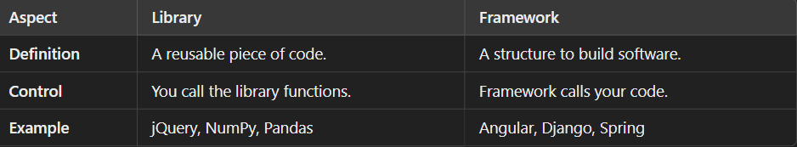a

JQuery introduction

What is jQuery?

jQuery is a lightweight, "write less, do more", JavaScript library.

The purpose of jQuery is to make it much easier to use JavaScript on your website.

jQuery takes a lot of common tasks that require many lines of JavaScript code to accomplish, and wraps them into methods that you can call with a single line of code.

jQuery also simplifies a lot of the complicated things from JavaScript, like AJAX calls and DOM manipulation.

The jQuery library contains the following features:

HTML/DOM manipulation

CSS manipulation

HTML event methods

Effects and animations

AJAX

Utilities

Ways to include jquery to your web page

1st Downloading jQuery

There are two versions of jQuery available for downloading:

* Production version - this is for your live website because it has been minified and compressed

So that gets easily transferred across web

* Development version - this is for testing and development (uncompressed and readable code)

To modify and understand better

Both versions can be downloaded from [jQuery.com](http://jquery.com/download/).

The jQuery library is a single JavaScript file, and you reference it with the HTML <script> tag (notice that the <script> tag should be inside the <head> section)

**NOte:** Place the downloaded file in the same directory as the pages where you wish to use it.

2nd jQuery CDN

If you don't want to download and host jQuery yourself, you can include it from a CDN (Content Delivery Network).

Flow of brower HTTP request: (assume JQuery used as file)

Index.html 🡪 Jquery file 🡪 store this file in cache for subsequent calls

In case of CDN:

Index.html 🡪 calls Jqeury file from nearest server 🡪 cache it for subsequent calls

What is $ in jquery?

$ is a function, and it behaves differently depending on the type of argument passed to it.

It is the core of the library and is used for almost everything in jQuery, such as:

* Selecting elements.
* Manipulating the DOM.(creating elements as well)
* Handling events.
* Performing animations.
* Making AJAX requests.

$ is function that acts according to argument passed

If $(‘div’) return all that div

If $(‘.class or #id’) return all class or ID

If $(‘<div> content </div>’) returns a new div and we can store it in something

If $(native dom element ) then it returns a Jqeury dom element that has additional methods

If $.fn.funName = function(){} then we add our own function to jquery

**What Does $ Return?**

The $ function always returns a **jQuery object**. A jQuery object is not the same as a native DOM element. Instead, it is a **wrapper** around native DOM elements that provides additional functionality.